|  |  |  |  |
| --- | --- | --- | --- |
| **Name of Student: NINAD AVINASH PATIL** | | | |
| **Roll No: 33** | | **Lab Practical Number: 6(A)** | |
| **Title of Lab Practical: Web Services**  **A. XML**  **1. Design an XML Web Service to access the methods of Bank Account class, consume this webservice using a web client.**  **2. Create an XML web service that returns all the student details from the student table. Write an Application that uses this service to display student details in DataGrid view control.** | | | |
| **DOP: 23/04/2021** | | **DOS: 30/04/2021** | |
| **CO Mapped: CO1** | **PO Mapped: PO3, PO5, PO7,**  **PO12, PSO1, PSO2** | **Faculty Signature:** | **Marks:** |

**Practical No 6(A)**

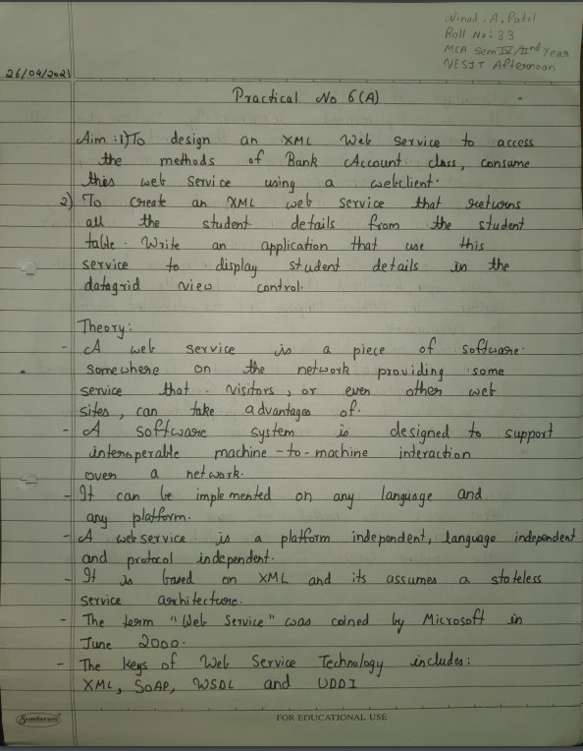

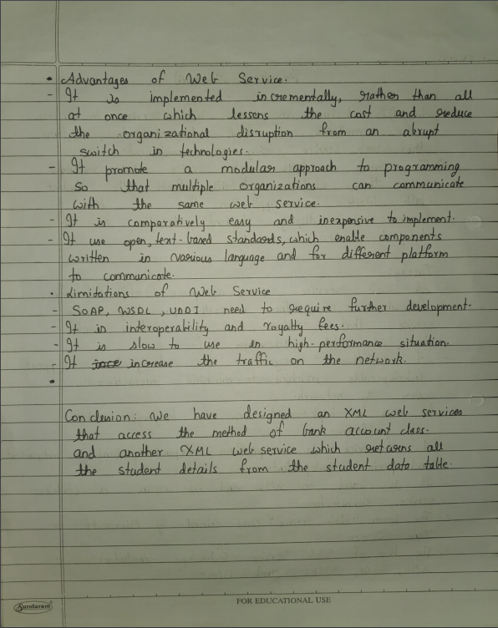

**Code:**

**1. Design an XML Web Service to access the methods of Bank Account class, consume this webservice using a web client.**

**Account.aspx**

<%@ Page Language="C#" AutoEventWireup="true" CodeBehind="Account.aspx.cs" Inherits="P6A.Account" %>

<!DOCTYPE html PUBLIC "-//W3C//DTD XHTML 1.0 Transitional//EN" "http://www.w3.org/TR/xhtml1/DTD/xhtml1-transitional.dtd">

<html xmlns="http://www.w3.org/1999/xhtml">

<head runat="server">

</head> <body>

<form id="form1" runat="server"> <div>

<asp:Label ID="Label1" runat="server" Text="Enter Amount : "></asp:Label>

<asp:TextBox ID="TextBox1" runat="server"></asp:TextBox>

<br /> <br />

<asp:Button ID="Button1" runat="server" Text="Check Balance" onclick="Button1_Click" />

&nbsp;<asp:Button ID="Button2" runat="server" Text="Deposit" onclick="Button2_Click" />

&nbsp;<asp:Button ID="Button3" runat="server" Text="Withdraw" onclick="Button3_Click" />

<br /> <br />

<asp:Label ID="Label2" runat="server"></asp:Label>

</div> </form>

</body>

</html>

**Account.aspx.cs**

using System;

using System.Collections.Generic;

using System.Linq;

using System.Web;

using System.Web.UI;

using System.Web.UI.WebControls;

namespace P6A

{

public partial class Account : System.Web.UI.Page {

double amount = 0.00;

Service bank;

protected void Page_Load(object sender, EventArgs e)

{ }

protected void Button1_Click(object sender, EventArgs e) {

bank = new Service();

Label2.Text = "Available Balance = Rs " + bank.getBalance().ToString(); }

protected void Button2_Click(object sender, EventArgs e) {

bank = new Service();

amount = Convert.ToDouble(TextBox1.Text);

bank.Deposit(amount);

Label2.Text = "Rs " + amount + " Successfully deposited"; }

protected void Button3_Click(object sender, EventArgs e) {

bank = new Service();

amount = Convert.ToDouble(TextBox1.Text);

bank.Withdraw(amount);

Label2.Text = "Rs " + amount + " Successfully withdrawn";

} } }

**Service.cs**

using System;

using System.Collections.Generic;

using System.Linq;

using System.Web;

using System.Web.Services;

namespace P6A

{

[WebService(Namespace = "http://tempuri.org/")]

[WebServiceBinding(ConformsTo = WsiProfiles.BasicProfile1_1)]

public class Service : System.Web.Services.WebService {

public Service()

{

//InitializeComponent();

}

private static double balance = 60000;

[WebMethod]

public void Deposit(double amount) {

balance += amount;

setBalance(balance);

}

[WebMethod]

public void Withdraw(double amount) {

if (balance < amount)

throw new Exception("Balance is not sufficient");

else {

balance -= amount;

setBalance(balance);

} }

[WebMethod]

public double getBalance() {

return balance;

}

private void setBalance(double bal) {

balance = bal;

} } }

**Output:**

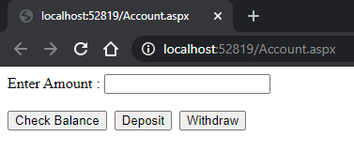

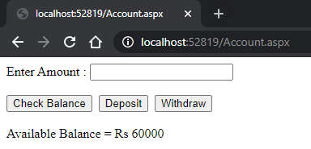

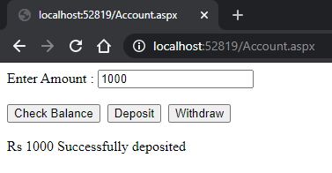

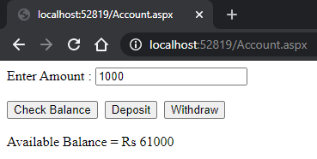

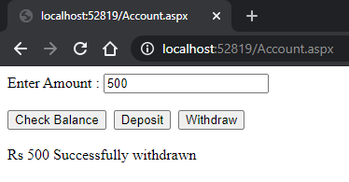

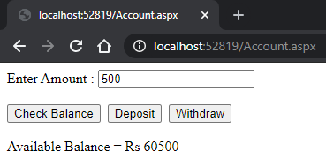

**2. Create an XML web service that returns all the student details from the student table. Write an Application that uses this service to display student details in DataGrid view control.**

**Data.aspx**

<%@ Page Language="C#" AutoEventWireup="true" CodeBehind="Data.aspx.cs" Inherits="P6A.Data" %>

<!DOCTYPE html PUBLIC "-//W3C//DTD XHTML 1.0 Transitional//EN" "http://www.w3.org/TR/xhtml1/DTD/xhtml1-transitional.dtd">

<html xmlns="http://www.w3.org/1999/xhtml">

<head runat="server">

<title></title>

</head> <body>

<form id="form1" runat="server"> <div>

<asp:Button ID="Button1" runat="server" onclick="Button1_Click" Text="Click here to view data" />

<br />

<asp:GridView ID="GridView1" runat="server">

</asp:GridView>

</div>

<asp:SqlDataSource ID="SqlDataSource1" runat="server" ConnectionString="<%$ ConnectionStrings:studentConnectionString %>" SelectCommand="SELECT * FROM [MCA]"></asp:SqlDataSource>

<br /> </form>

</body>

</html>

**Data.aspx.cs**

using System;

using System.Collections.Generic;

using System.Data;

using System.Linq;

using System.Web;

using System.Web.UI;

using System.Web.UI.WebControls;

using System.Web.Services;

namespace P6A

{

public partial class Data : System.Web.UI.Page {

WebService1 ws = new WebService1();

protected void Page_Load(object sender, EventArgs e)

{ }

protected void Button1_Click(object sender, EventArgs e) {

DataSet ds = new DataSet();

ds = ws.GetData();

GridView1.DataSource = ds;

GridView1.DataBind();

} } }

**WebService1.asmx**

using System;

using System.Collections.Generic;

using System.Linq;

using System.Web;

using System.Web.Services;

using System.Web.Configuration;

using System.Data;

using System.Data.SqlClient;

namespace P6A

{

/// <summary>

/// Summary description for WebService1

/// </summary>

[WebService(Namespace = "http://tempuri.org/")]

[WebServiceBinding(ConformsTo = WsiProfiles.BasicProfile1_1)]

[System.ComponentModel.ToolboxItem(false)]

// To allow this Web Service to be called from script, using ASP.NET AJAX, uncomment the following line.

// [System.Web.Script.Services.ScriptService]

public class WebService1 : System.Web.Services.WebService {

string conn = WebConfigurationManager.ConnectionStrings["studentConnectionString"].ConnectionString;

[WebMethod]

public DataSet GetData() {

using (SqlConnection con = new SqlConnection(conn)) {

string query = "select * from MCA";

SqlCommand cmd = new SqlCommand(query, con);

SqlDataAdapter sda = new SqlDataAdapter(cmd);

DataSet ds = new DataSet();

sda.Fill(ds);

return ds;

} } } }

**Output:**

